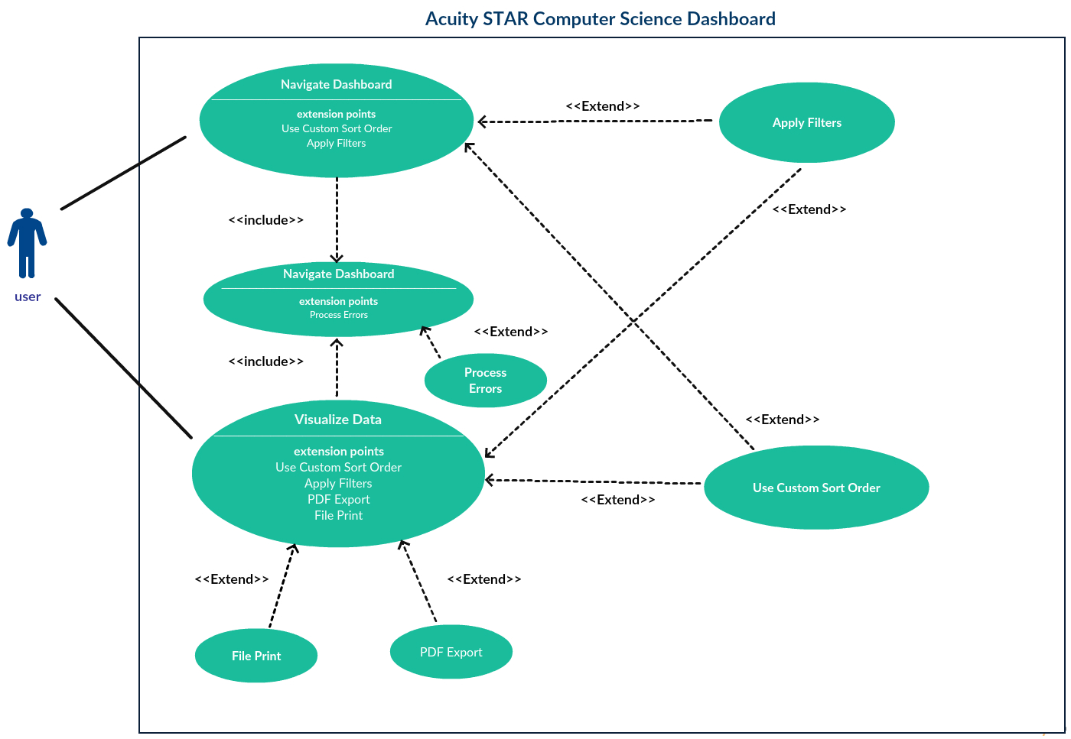

Above is the Acuity STAR use case diagram. A user refers to anyone running the program, be it a faculty member, department manager, or anyone authorized to use the program. Each user has two use cases, namely “Navigate Dashboard” and “Visualize Data”. Each of these use cases corresponds to a customer requirement: Navigate Dashboard addresses the dashboard screen requirement, while Visualize Data addresses the visualizations requirement. Note that both of these use cases include another use case, “Load Data from File”, which addresses the CSV file data processing requirement. The other use cases are extensions going on beyond the user requirements and reflect our stretch goals. Below are the texts for each use case:

**1.1 Loading data from file**

Load Data from File (Sea Level)

Main Success Scenario:

1. The user clicks on a subject area tab (default is Teaching).
2. The user clicks the Load button.
3. The system displays a file structure screen.
4. The user selects a CSV file and clicks the Open button. [Alternate Course A: File is not CSV  type] [Alternate Course B: User clicks Cancel button]
5. The system verifies if the records contain any missing fields. [Extension Point: 3*.1.2 Error*  *processing*]
6. The system loads the records.

Alternate Course A: File is of invalid type

1. The system displays an error message.
2. The user accepts or closes the error message.

Alternate Course B: User clicks Cancel button

 1. The system closes the file structure screen.

**1.2 Error processing**

Process Errors (Sea Level)

Main Success Scenario:

1. The system displays message showing number of invalid records and prompts user to edit or discard them.
2. The user clicks Edit button. [Alternate Course A: User clicks Discard button]
3. The system displays an error processing screen.
4. The user fills in all missing entries and clicks the Save button. [Alternate Course B: All entries  not filled out] [Alternate Course C: User clicks Cancel button]
5. The system includes the newly modified records in the data to be loaded
6. The system closes the error processing screen.

Alternate Course A: User clicks Discard button

1. The system discards records with missing mandatory entries from the data to be loaded.
2. The system closes the error processing screen.

Alternate Course B: All entries are not filled out

1. The system displays an error message.
2. The user accepts or closes the error message. [Return to Main Success Scenario step 4]

Alternate Course C: User clicks Cancel button

1. The system discards records with missing mandatory entries.
2. The system closes the error processing screen.

**1.3 Navigating the dashboard**

Navigate Dashboard (Sea Level) Main Success Scenario:

1. The user loads the data from file via the use case 3*.1.3 Loading data from file.* [Extension Point: 3*.1.4 Applying filters*. Applicable to step 3.] [Extension Point: *Using a custom sort order*. Applicable to step 3.]
2. The system displays the updated dashboard summary view.
3. The user expands/collapses elements of the dashboard summary view.
4. The system displays the expanded/collapsed elements of the dashboard summary view.

**1.4 Applying Filters**

Apply Filters (Sea Level)

Main Success Scenario:

1. The user modifies the values in the start and end date boxes.
2. The system sets its date range according to the values in the start and end date boxes.
3. The user modifies the values in the first and last letter of member last name boxes.
4. The system sets its member name range according to the values in the first and last letter of  member last name boxes.

**1.5 Using a custom sort order**

Use Custom Sort Order (Sea Level)

Main Success Scenario:

1. The user clicks Create New Sort Order button. [Alternate Course A: User selects existing sort order]

1. The system displays a new sort order screen.
2. The user enters the name of the new sort order, selects the hierarchy of filters to order the sort  by, and clicks the Save button. [Alternate Course B: User does not enter name] [Alternate  Course C: User clicks Cancel button]
3. The system closes the new sort order screen.
4. The system adds the new sort order to the list of existing sort orders.
5. The user selects the sort order from the list of existing sort orders.
6. The system sets its sort order to the one selected in the list of existing sort orders.

Alternate Course A: User selects existing sort order

1. [Return to Main Success Scenario step 6]

Alternate Course B: User does not enter name

1. The system displays an error message.
2. The user accepts or closes the error message. [Return to Main Success Scenario step 3]

Alternate Course C: User clicks Cancel button

1. The system closes the new sort order screen.

**1.6 Visualizing data**

Visualize Data (Sea Level)

Main Success Scenario:

1. The user loads the data from file via the use case 3*.1.3 Loading data from file.* [Extension Point: 3*.1.4 Applying filters*. Applicable to step 3] [Extension Point: *Using a custom sort order*. Applicable to step 3]
2. The system displays the dashboard summary view.
3. The user clicks on an element in the dashboard summary view. [Extension Point: *3.1.7*  *Exporting to PDF*. Applicable to step 5] [Extension Point: *Printing to file*. Applicable to step 5]
4. The system displays a visualization (default is Pie Chart) of the selected element.
5. The user clicks on the Bar Graph radio button.
6. The system displays a bar graph of the selected element.

**1.7 Exporting to PDF**

PDF Export (Sea Level) Main Success Scenario:

1. The user clicks the Export button.
2. The system displays a file structure screen.
3. The user selects a file path, enters a file name and clicks the Save button. [Alternate Course A:  No file name entered] [Alternate Course B: User clicks Cancel button]
4. The system exports the selected visualization type to a PDF with the entered file name at the  selected file path.

Alternate Course A: No file name entered

1. The system displays an error message.
2. The user accepts or closes the error message. [Return to Main Success Scenario step 3]

Alternate Course B: User clicks Cancel button

1. The system closes the file structure screen.

**1.8 Printing to File**

File Print (Sea Level)

Main Success Scenario:

1. The user clicks the Print button.
2. The system displays a file structure screen.
3. The user selects a file path (default is current working directory), enters a file name (default is  “print”) and clicks the Print button. [Alternate Course A: No file name entered] [Alternate  Course B: User clicks Cancel button]
4. The system exports the selected visualization type to a PDF with the entered file name at the  selected file path.

Alternate Course A: No file name entered

1. The system displays an error message.
2. The user accepts or closes the error message. [Return to Main Success Scenario step 3]

Alternate Course B: User clicks Cancel button

1. The system closes the file structure screen.